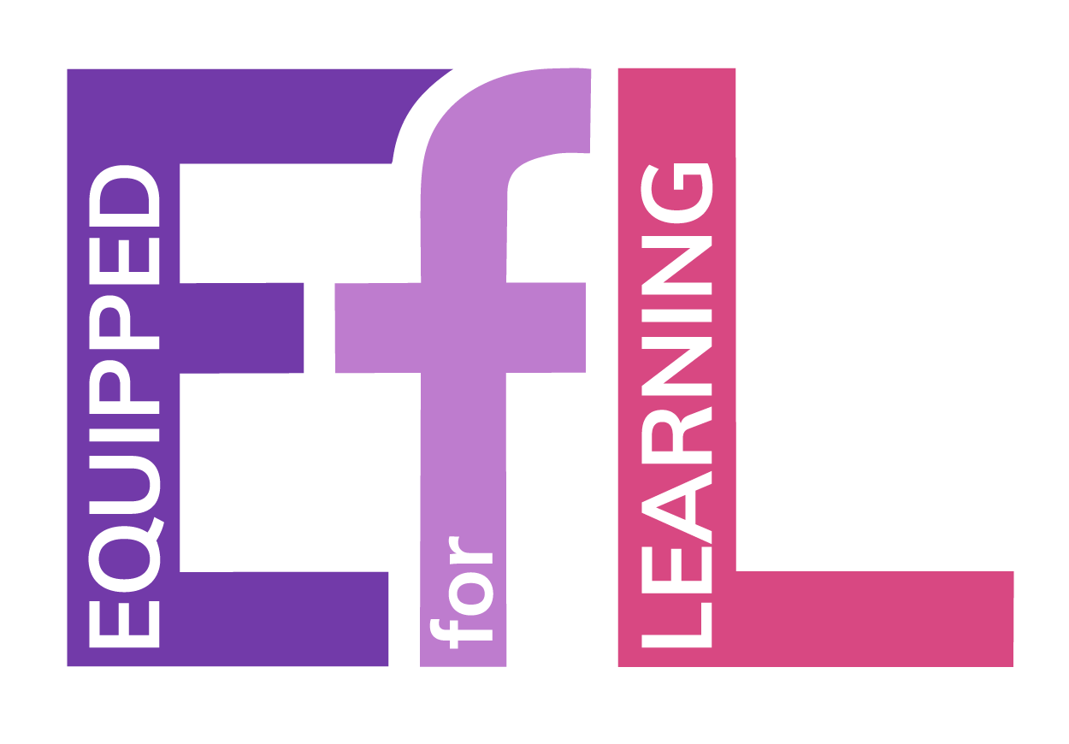

Equipped for Learning
Digital Devices for Learning
Parent/Carer Information

As part of Midlothian Council’s Equipped for Learning programme, a digital device for learning is being provided to every child of school age. This is to ensure that all young people have access to the technology they need for learning, both at school and at home. This document provides information about the programme structured in the format of frequently asked questions.

A Parent/Carer agreement is also included in this document. Your acknowledgement of this agreement is required prior to your child being provided with a device.

When will my child receive their device?
Devices are being provided as part of an accelerated rollout programme from September 2021 to January 2022. Specific dates will be provided by your school using the school’s communication methods.

What type of device will my child receive?
Midlothian Council are providing a mixture of iPad and Chromebook devices. For younger learners, the iPad best suits the needs of Midlothian’s curriculum. As learning becomes more varied and the curriculum increases in complexity, the flexibility of the Chromebook ensures digital technology can support learning in any context. iPad devices will be supplied in a protective case and Chromebook devices will be supplied in a protective sleeve.
How long will my child have access to a device?
Midlothian Council’s commitment is that every young person will have access to a device for learning until they leave formal education. We may swap your child’s device to provide a more up-to-date model.

Can devices be taken home?
Yes, the devices being provided aim to support young people with learning both in school and at home. However, this is at the sole discretion of your child’s Head Teacher. Additionally, schools may initially request that devices stay in school for a period of time to allow young people to be taught how to use the devices and look after them responsibly.

How will devices be charged?
Devices should be charged only with the charging cables provided with the device. These have undergone electrical testing or are within two years of manufacture. Wherever possible, devices should come to school every day fully charged and ready for use in their protective case or sleeve. Building this positive habit at home will be beneficial to your child’s learning in the longer term.
Will my child and I receive support to use the device?
Young people will be given the necessary support required during school to connect to the internet and to access cloud-based storage and learning platforms. This forms part of Midlothian Council’s Digital Literacy curriculum. The Digital Inclusion & Learning Team is hosting a series of webinars for parent/carers and young people to ensure you feel confident to support your child. Further information on these can be found on the Equipped for Learning website. (click to access)

What happens if the device stops working?
While it is expected that young people will take appropriate measures to ensure that the device avoids damage, the maintenance and technical support of the device is the responsibility of Midlothian Council’s Digital Inclusion & Learning Team. Young people should not attempt to fix the device if it is not working and under no circumstances should you or your child remove screws or attempt to take the device apart. Instead, you should report the problem directly to your child’s school. Where a device has been damaged, lost or stolen Midlothian Council is not obliged to provide a replacement personal device. Where there is evidence of willful damage to the device or negligence in caring for the device, the school will work with the young person and parent/carers in line with the schools’ approach to promoting positive behaviour and inclusion.

What will my child use the device for?
Devices are being provided to support your child’s learning. Teachers will use digital resources to deliver the curriculum and will make use of learning platforms such as Google Workspace, Office 365 and/or Seesaw. Additionally, your child may be required to access the internet to research information or use an application to showcase their knowledge in a creative way. Midlothian Council also wish to provide a range of
additional learning tools which require parent/carer consent. A list of these tools is included in the Education Service’s Privacy Notice. (click to access)

Are there restrictions on the use of the device?
The use of digital devices on school grounds is at the discretion of school staff. All young people must use their devices as directed by their teacher or any member of school staff. The use of digital devices at home should be primarily for educational purposes. Digital devices should stay within the United Kingdom, unless permission is sought to support learning in specific circumstances. A device management system tracks devices, identifies date and time of use, provides software updates and can be used to disable the device if it is lost or stolen.

How is my child’s safety and security protected when using the device?
All activity on the device, both in school and from any other location, is logged and catalogued by sophisticated education-specific tools. This system is actively monitored by Midlothian Council’s Digital Inclusion & Learning Team and by senior school staff. This data is treated as confidential and is managed by Midlothian Council in accordance with the requirements of the General Data Protection Regulation (‘GDPR’) and in line with Midlothian Council’s Privacy Policy. (click to access) Midlothian Council does not use the device camera to capture images of your child but safeguarding reports may include an image of the windows visible on the device screen. Any child protection concerns identified by Midlothian staff will immediately trigger a school’s Child Protection and Safeguarding policy.

What happens if my child accesses inappropriate content?
In the majority of cases, this content will be blocked and recorded by internet filtering and safeguarding tools. However, no guarantee can be given that this system will block all inappropriate content on the internet. Where a young person comes across inappropriate online content that is distressing or illegal this should be immediately reported to the child’s school. Where there is a concern that viewed content is illegal, this should be reported to the Police through CEOP. (click to access)

What happens if my child does not use their personal device appropriately?
Where a young person is in persistent or serious breach of the appropriate use of the device, it will be recalled by the school. If any activity is unlawful, this will be reported to the Police. Learners should be respectful and considerate in all forms of communication when using a school device.

My child prefers to use a different device. Can they bring that to school instead?
At home young people can select technology which best suits their needs. It is a requirement for the Midlothian Council-issued device to be used in school. This ensures an equitable experience for all young people and allows our staff to best support your child.

Equipped for Learning
Digital Devices for Learning
Parent/Carer Agreement

This agreement summarises the Equipped for Learning Parent/Carer Information document and requests that you acknowledge your acceptance by completing an online form.

Key Points and Guidelines
- Young people and parent/carers are responsible for the safekeeping and security of the loaned device.
- Young people will be supported by school staff and the Midlothian Digital Inclusion & Learning Team to learn to access the internet, charge and keep the device safe. Additional help guides can be found on the Equipped for Learning website.
- Young people should follow instructions and guidance from school staff on the use of any device in school.
- Devices should, as far as possible, be brought to school each day fully charged and ready to be used for learning.
- All activity on the device is actively monitored by Midlothian Council’s Digital Inclusion & Learning Team and by senior school staff.
- If a young person comes across distressing or illegal material or behaviour when online they should report this to their teacher or their parent/carer immediately.
- Young people should be mindful at all times that the content they access is appropriate for educational purposes and that their communications online are respectful.
- Midlothian Council are providing a range of additional learning tools which require parent/carer consent. Your consent will be collected within the acknowledgement online form.
- Parent/carers or young people should not attempt to fix a device, replace or remove parts from a device.
- Where a device is not working, lost, damaged or stolen this should be immediately reported to the school.
- Where a device has been damaged, lost or stolen Midlothian Council is not obliged to provide a replacement device.

Click here to Complete the Acknowledgement Online Form
This form must be completed before your child receives their allocated device.

